OBD GPS TRACKER
Specification

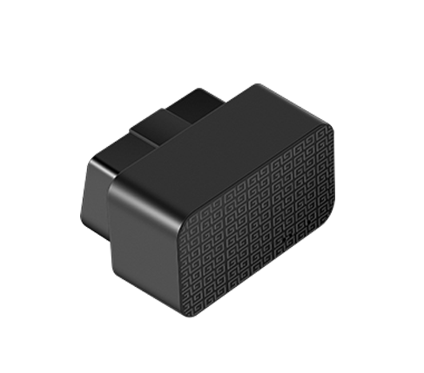

Specification | parameters
SIZE | 47.4*33.2*27.6mm
WEIGHT | 32.5g (include battery)
INTERNAL BATTERY | 100mAH（3.7V）
Working voltage | 12-36V DC
GSM+GPS model | MT2503
Working temperature | -20°C to+60°C
Restore temperature | -20°C to+70°C
sensor | Precision vibration sensor
Frequency band | Quad-band：850/900/1800/1900MHZ
GPRS | Class2,TCP/IP build in GSM Module
Root mean square error | S degree
Max output power | GSM 850/900:33.0±2dbm  GSM 1800/1900:30.0±2dbm
Dynamic output range | -15~-108dbm
Receiving sensitivity | -107dbm
Maximum frequency error | ±0.1ppm
sensitivity | Code start：-145 dbm  Hot start：-156 dbm  Normal temperature start：-145 dbm  navigation：-160 dbm  track：-162 dbm
Location accuracy | ＜5m
First time location | Cold start：normal 32 S
GSM antenna | internal
GPSantenna | internal
LED light | Power source, status
Transfer protocol | TCP
Power detection | Report when main power disconnected
Data report | Report real time data
E-fence | TBD
Over speed alarm | Over speed alarm, (need setting)
GPS data | Update in real time
Vibration alarm | Report vibration alarm when setup defence.

